

**Name of the Assignment :** Women's role in society and culture in Bangladesh and Major Economic Sector of Bangladesh (IIT)

**Course Tittle :** Bangladesh Studies

**Course Code :** ICT-1209

**Submitted To Submitted By**

[Ananna Zulfiqar Showly](https://juniv.edu/teachers/ananna.showly) Nahidul Islam

Lecturer Roll-2028

Department of Archaeology 1st year 2nd Semester

IIT-JU

Women's role in society and culture in Bangladesh

Introduction:

About 82 percent of women lived in rural areas in the late 1980s. The majority of rural women, perhaps 70 percent, were in small cultivator, tenant, and landless households; many worked as laborers part time or seasonally, usually in post-harvest activities, and received payment in kind or in meager cash wages. Another 20 percent, mostly in poor landless households, depended on casual labor, gleaning, begging, and other irregular sources of income; typically, their income was essential to household survival. The remaining 10 percent of women were in households mainly in the professional, trading, or large-scale landowning categories, and they usually did not work outside the home.

The economic contribution of women was substantial but largely unacknowledged. Women in rural areas were responsible for most of the post-harvest work, which was done in the *chula*, and for keeping livestock, poultry, and small gardens. Women in cities relied on domestic and traditional jobs, but in the 1980s they increasingly worked in manufacturing jobs, especially in the readymade garment industry. Those with more education worked in government, health care, and teaching, but their numbers remained very small. Continuing high rates of population growth and the declining availability of work based in the *chula* meant that more women sought employment outside the home. Accordingly, the female labor force participation rate doubled between 1974 and 1984, when it reached nearly 8 percent. Female wage rates in the 1980s were low, typically ranging between 20 and 30 percent of male wage rates.

Women’s ability to enjoy civil, political, economic, social and cultural rights is interlinked with the issue of discrimination. Discrimination based on gender ideology and patriarchy was not initially considered as part of the human rights agenda. Excluding sex discrimination and violence against women from the human rights agenda also results from a failure to see the oppression of women as political.Female subordination runs so deep that it is still viewed as inevitable or natural rather than as a politically constructed reality maintained by patriarchal interests, ideology, and institutions.

Literacy

Women are much less likely than men to be literate. In South Asia, female literacy rates are only around 50% those of males ,in Nepal 35% . Women make up two-thirds of the world’s illiterates.

Higher education

Women in developing countries lag far behind men. Even in industrial countries, women are very poorly represented in scientific and technical study .

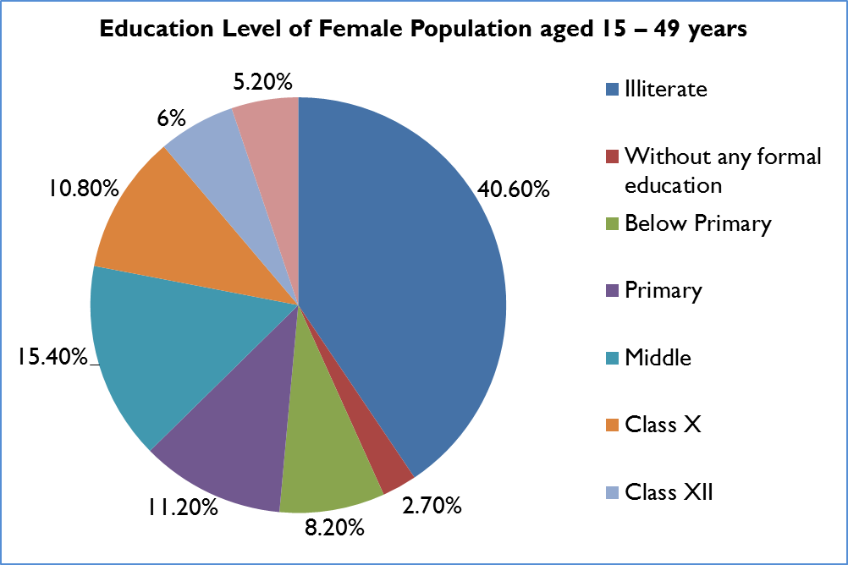

Employment

In developing countries women have many fewer job opportunities, the employment participation rates of women are on average only 50% those of men (in South Asia 29%) .Wage discrimination is also a feature of industrial countries. Women who are not in paid employment are, of course, far from idle.Indeed, they tend to work much longer hours than men .

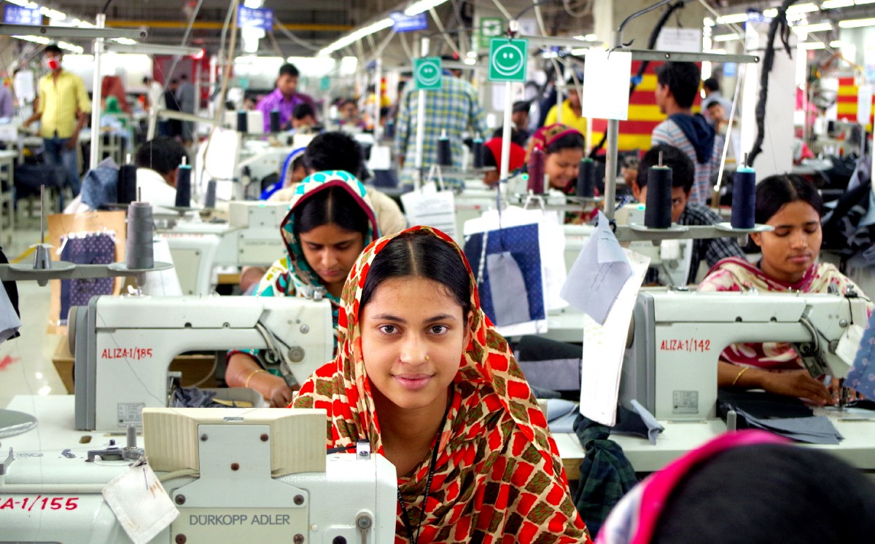

Health

Women tend on average to live longer than men.But in some Asian country, the discrimination against women—through neglect of their health or nutrition—is such that they have a shorter life expectancy

National statistics

Women are often invisible in statistics. If women’s unpaid housework were counted as productive output in national income accounts, global output would increase by 20-30%

## Politics

## Women politician in Bangladesh:

## 1.Shirin Sharmin Chaudhury is the current and the first woman speaker of the [Jatiya Sangsad](https://en.wikipedia.org/wiki/Jatiya_Sangsad) since April 2013.

## 2. Matia Chowdhury is a Bangladeshi politician, and the incumbent Member of Parliament from [Sherpur-2](https://en.wikipedia.org/wiki/Sherpur-2). She is a presidium member of [Bangladesh Awami League](https://en.wikipedia.org/wiki/Bangladesh_Awami_League), and was the Minister of Agriculture under the prime ministership of [Sheikh Hasina](https://en.wikipedia.org/wiki/Sheikh_Hasina).

3.Dipu Moni is a [Bangladeshi](https://en.wikipedia.org/wiki/Bangladesh) politician who is serving [Bangladesh Government](https://en.wikipedia.org/wiki/Government_of_Bangladesh) as the [Minister of Education of Bangladesh](https://en.wikipedia.org/wiki/Ministry_of_Education_(Bangladesh)) since January 2019. She served Bangladesh as [Foreign Minister of Bangladesh](https://en.wikipedia.org/wiki/Minister_of_Foreign_Affairs_(Bangladesh)) from 2009 to 2013

4.Sheikh Hasina is a Bangladeshi politician serving as the 10th [Prime Minister of Bangladesh](https://en.wikipedia.org/wiki/Prime_Minister_of_Bangladesh), having held the office since January 2009. She had previously served as Prime Minister from 1996 to 2001. She is the longest-serving prime minister in the history of Bangladesh.

5. Ivy Rahman was a Bangladeshi politician. She was the Women's Affairs secretary of [Awami League](https://en.wikipedia.org/wiki/Awami_League).

6.Khaleda Zia is a [Bangladeshi](https://en.wikipedia.org/wiki/Bangladesh) politician who served as the [Prime Minister of Bangladesh](https://en.wikipedia.org/wiki/Prime_Minister_of_Bangladesh) from 1991 to 1996, and again from 2001 to 2006. She was the first woman in the country's history and second in the [Muslim majority countries](https://en.wikipedia.org/wiki/List_of_Muslim_majority_countries) to head a democratic government as prime minister.

## SPORTS:

## 1. Name of some Bangladeshi women cricketers:

* [Rumana Ahmed](https://en.wikipedia.org/wiki/Rumana_Ahmed)
* [Ayesha Akhter](https://en.wikipedia.org/wiki/Ayesha_Akhter)
* [Sharmin Akhter](https://en.wikipedia.org/wiki/Sharmin_Akhter)
* [Shohely Akhter](https://en.wikipedia.org/wiki/Shohely_Akhter)
* [Tazia Akhter](https://en.wikipedia.org/wiki/Tazia_Akhter)
* [Nahida Akter](https://en.wikipedia.org/wiki/Nahida_Akter)

2. Name of some Bangladeshi women footballers:

* [Akhi Khatun](https://en.wikipedia.org/wiki/Akhi_Khatun)
* [Sabina Khatun](https://en.wikipedia.org/wiki/Sabina_Khatun)
* [Tohura Khatun](https://en.wikipedia.org/wiki/Tohura_Khatun)
* [Shamsunnahar](https://en.wikipedia.org/wiki/Shamsunnahar_(footballer,_born_2003))
* [Mosammat Sirat Jahan Shopna](https://en.wikipedia.org/wiki/Mosammat_Sirat_Jahan_Shopna)

Literature:

List of notable women writers who were born in Bangladesh:

* + 1.[Roquia Sakhawat Hussain](https://en.wikipedia.org/wiki/Roquia_Sakhawat_Hussain) (1880–1932), essayist, short story writer, novelist, poet, feminist, author of [Sultana's Dream](https://en.wikipedia.org/wiki/Sultana%27s_Dream).
  + 2**.**[Jahanara Imam](https://en.wikipedia.org/wiki/Jahanara_Imam) (1929–1994), non-fiction writer, diarist, political activist.
  + 3. Sufia Kamal(1911–1999), poet, feminist.
  + 4. [Husne Ara Shahed](https://en.wikipedia.org/wiki/Husne_Ara_Shahed)**,** contemporary novelist, non-fiction writer, educator.
  + 5. [Iffat Ara](https://en.wikipedia.org/wiki/Iffat_Ara) (born 1939), novelist, short story writer, essayist, magazine editor, educator, women's rights activist.

**Major Economic Sector of Bangladesh (IIT)**



Introduction :

Bangladesh is a developing country and the economy of Bangladesh mainly depends on the sector of Agriculture,Industry,Manufacturing even recently IT play a important role in our economy . We can’t think the modern world without IT.USA,China,Japan,Russia are rich in IT but recently out IT sector is also increasing day by day . According to the IMF, the Bangladeshi economy was the second fastest growing major economy of 2016, expanding at an annual growth rate of 7.1%. GDP growth rate above 6% sice 2005.

Most Important Economic Sectors in Bangladesh :

The most important economic sectors in Bangladesh are agriculture, manufacturing, and finance,IT,RMG etc. Economy SectLevel can be shown by this graph.Economy SectLevel can be shown by this graph.

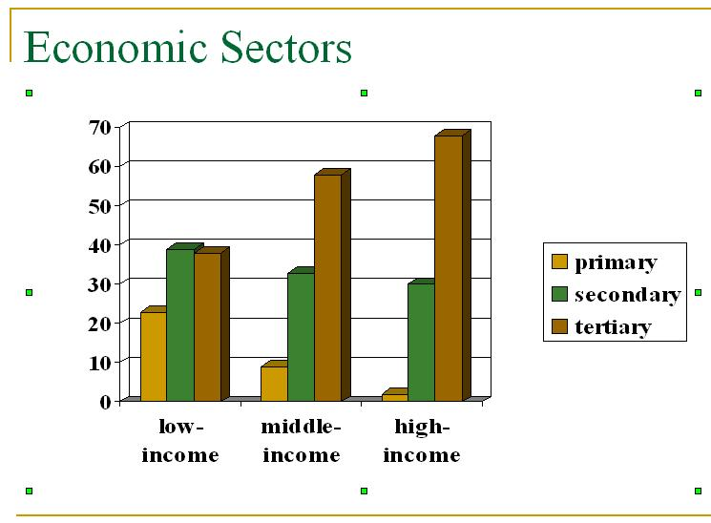

IT Sector in Bangladesh :

The first computer in Bangladesh was an [IBM mainframe](https://en.wikipedia.org/wiki/IBM_mainframe) [1620 series](https://en.wikipedia.org/wiki/IBM_1622), installed in 1964 at the [Dhaka](https://en.wikipedia.org/wiki/Dhaka) center of the [Pakistan Atomic Energy Commission](https://en.wikipedia.org/wiki/Pakistan_Atomic_Energy_Commission) (later the [Bangladesh Atomic Energy Commission](https://en.wikipedia.org/wiki/Bangladesh_Atomic_Energy_Commission)). Computer use increased in the following years, especially after the [independence of Bangladesh](https://en.wikipedia.org/wiki/Bangladesh_liberation_war) in 1971; more-advanced IT equipment began to be set up in different educational, research and financial institutions. In 1979, a computer centre, later renamed Department of Computer Science & Engineering, was established at [Bangladesh University of Engineering and Technology](https://en.wikipedia.org/wiki/Bangladesh_University_of_Engineering_and_Technology) BUET. In 1983, the [Ministry of Science and Technology](https://en.wikipedia.org/wiki/Ministry_of_Science_and_Technology_(Bangladesh)) established a National Computer Committee to create the required policies. The committee was also responsible to carry out programs to expand and promote the efficacious use of the sector. In 1988, the committee was replaced by the National Computer Board. In 1990, the ministry reformed the board and reconstituted it as the [Bangladesh Computer Council](https://en.wikipedia.org/wiki/Bangladesh_Computer_Council) to monitor computer- and IT-related works in the country. The ICT industry is a relatively new sector in the country's economy. Though it is yet to make tangible contributions in the national economy, it is an important growth industry. The [Bangladesh Association of Software and Information Services](https://en.wikipedia.org/wiki/Bangladesh_Association_of_Software_and_Information_Services) (BASIS) was established in 1997 as the national trade body for software and IT service industry. Starting with only 17 member companies, by 2009 membership had grown to 326. In a study among Asian countries by [Japan International Cooperation Agency](https://en.wikipedia.org/wiki/Japan_International_Cooperation_Agency) in 2007–08, Bangladesh was ranked first in software and IT services competitiveness and third in competencies, after India and China.The [World Bank](https://en.wikipedia.org/wiki/World_Bank), in a study conducted in 2008, projected triple digit growth for Bangladesh in IT services and software exports. Bangladesh was also listed as one of the top 30 Countries for Offshore Services in 2010–2011 by [*Gartner*](https://en.wikipedia.org/wiki/Gartner). The [Internet penetration](https://en.wikipedia.org/wiki/Broadband_universal_service) has also grown to 21.27 percent in 2012, up from 3.2 percent three years prior. But still Bangladeshi people are not so qualified to use ICT. So Bangladeshi government is giving much priority in it. If Bangladesh wants to become digital Bangladesh, she must make sure of giving ICT education to her childrens and therefore Bangladesh can make the best use of it. From a TV source of Bangladesh, government agreed to give the light of programming knowledge to the childrens from the primary level of their life.

The Information and Communications Technology (ICT) sector of the country has maintained 57.21 percent export growth on an average over the last nine years since 2009. In the fiscal year (FY) 2016-17, Bangladesh ICT sector registered export earnings worth US$0.8 billion from the global market and US$1.54 billion from the domestic market span - thereby making around one percent contribution to the gross domestic product (GDP).The ICT sector has created around three hundred thousand job opportunities so far.As the Internet usage increases, the government expects the IT sector to add 7.28 percent to GDP growth by 2021.

Some of IT of our country are given blew.

Software: In our everyday life we use so many software for game,entertenment ,accounting and son on.for the last five we creat many software and export in different country.The given blew graph shows the growth rate of different years.

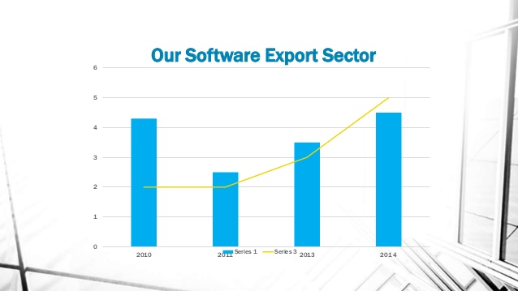

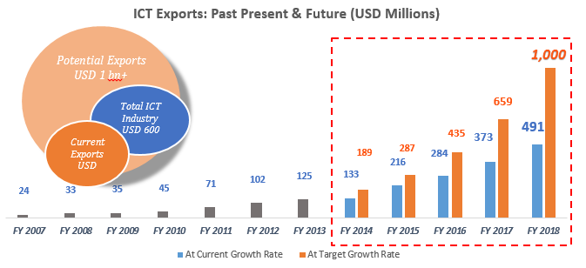

**E-business:** Nowadays E-business && E-commerce become popular for all classes people.Everyday we sell and buy our product from online evaly.com,foodpanda bikroy.com etc.

